Sermon

Sunday 4 July 2021

The grass withers, the flower fades, but the word of our God will stand forever

Isaiah 40:8

&

Heaven and earth will pass away, but My words will not pass away.

Matthew 24:35

Replacing God: The CCP’s Century Long War Against Faith

What does it mean to be an enemy of God?

An enemy is one who dislikes or hates another and seeks to harm, contradict, and fight the one he is set against. Thus, an enemy of God is one who opposes the presence and purposes of God in this world.

Introduction:

Over time there have been many attempts to disintegrate the word of God. To wipe the word of God totally off the face of the earth and God’s people as well. Satan is always trying and manipulating man into thinking there is no God or man doesn’t need God. The example of what Satan was allowed to do to Job in the hopes that Job would “curse God and die.” The book of Esther is one example that we just heard a sermon over a few short weeks ago where Haman tricked King Ahasuerus (King Xerxes) into passing a law that would annihilate or wipe off the face of the earth the Jewish race.

Other words used to describe an enemy of God is adversary or foe. Any of us who disobey God’s command’s is considered His enemy. With this in mind sin sets us against God: “Once you were alienated from God and were enemies in your minds because of your evil behavior” (Colossians 1:21). Paul, the apostle, referred to unsaved sinners as enemies of God: “For our friendship with God was restored by the death of his Son while we were still his enemies, we will certainly be saved through the life of His Son” (Romans 5:10)

Israel’s history is filled with people who were intent and committed to the destruction of God’s people. The Canaanites, the Philistines, and the Babylonians mentioned in the Old Testament and were considered Israel’s enemies as God’s people and God’s enemies as well. God fought on Israel’s behalf (2 Kings 19).

Throughout the life of Christ, He was opposed by human and spiritual enemies as told to us in scripture (Genesis 3:15). Herod the Great tried but failed to have the infant Jesus killed (Matthew 2:13, 16-20). Satan tempted Christ in the wilderness (Mark 1:12-13). At times Satan opposed the Lord through His friends and followers (Matthew 16:22-23; 26:14-16; Luke 22:3; John 13:21-27). As predicted in Old Testament Scripture (Psalm 2:2; Isaiah 53:3), the Jewish leaders plotted to kill Jesus (Matthew 12:14; 17:1; Mark 3:6; John 5:18; 7:1,19; 11:53).

Replacing God:

The CCP’s Century-Long War Against Faith
BY EVA FU AND FRANK FANG July 2, 2021 Updated: July 2, 2021

Priests and nuns were forced to kneel down in front of a large bonfire, watching helplessly as the flames devoured their sacred instruments and burned their skin.

In another Chinese city, students wearing red armbands hit Catholics with sharp wooden sticks, throwing one priest into a fire pit after he collapsed in pain. They beat one nun to death after she refused to stomp on a statue of the Virgin Mary.

One Catholic priest was buried alive in Beijing after declining to give up his faith.

Unsettling as they might be, these acts of brutality documented by Hong Kong-based missionary Sergio Ticozzi were hardly out of the norm for faithful Chinese during the frenzy of the decade-long Cultural Revolution from 1966, when all forms of religious practices were declared “superstitious” and banned.
Nor was such repression unique to that particular period during the regime’s more than 70 years of ruling China.

Total Control

Belief in a higher power is anathema to the atheist Chinese Communist Party (CCP) that for 100 years has sought to command absolute loyalty and control over its members and the Chinese people.

“They just cannot handle an allegiance other than to the state,” Sam Brownback, former U.S. ambassador-at-large for international religious freedom, told The Epoch Times.
As a result, successive Party leaders have launched campaign after campaign to crush and control people of faith in China.

Mao Zedong, the first CCP leader, who oversaw one of the most thorough campaigns to dismantle Chinese religious life, compared religion to “poison” in a conversation with Tibet’s exiled leader, the Dalai Lama. In his autobiography, the Dalai Lama recalls Mao telling him in 1954 that religion “undermines the race” and “retards the progress of the country.”

Former Chinese leader Jiang Zemin in 1993 declared religious freedom to be “unsuitable for Party members” and told Party members to “patiently educate” those with faith to help them “get rid of religious shackles.”

Buddhism, Taoism, Islam, Catholicism, and Christianity—the five religions the regime has officially sanctioned—remain under rigid state control, with Party officials setting the terms on how they operate.

Chinese officials for religious affairs have stressed the need to “guide religion with socialist values” and for devotees to possess “gratitude toward the Party.”
Under the Party’s rules, members also face possible expulsion for believing in religion or engaging in “superstitious activities.”

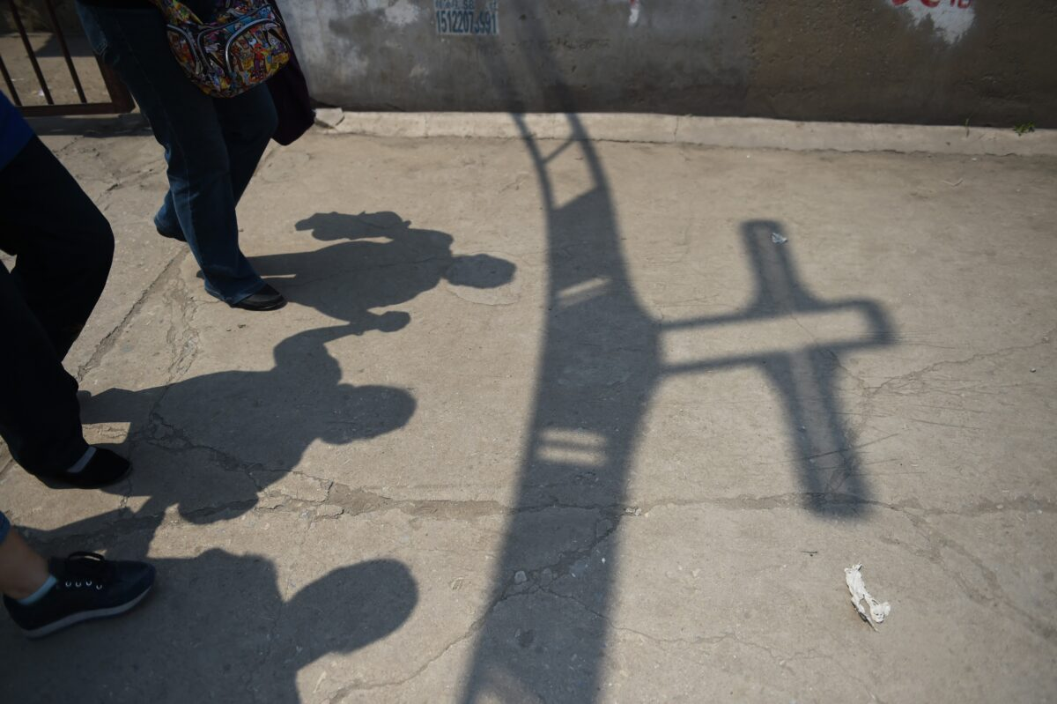
<img class="size-large wp-image-3884661" src="https://img.theepochtimes.com/assets/uploads/2021/07/02/GettyImages-479276502-1200x799.jpg" alt="CHINA-RELIGION-POLITICS-CATHOLIC" width="640" height="426" /> Worshippers walk past the shadow of a cross at the entrance to the “underground” Zhongxin Bridge Catholic Church, after a service celebrating the Feast of the Ascension in Tianjin, on May 24, 2015. (Greg Baker/AFP via Getty Images)

Marking the Party’s centennial, the heads of six state-level religious associations met in June and extolled the CCP leadership. Expressing resolve to “always follow the Party,” they pledged to begin an education campaign to deepen “love for the Party” among their religious circles.
Pastor Bob Fu, the founder of Christian human rights group China Aid, described the CCP as the “world’s largest extreme atheistic Party.”

“[The] CCP has committed the worst religious persecution and crimes against humanity,” Fu told The Epoch Times.
In the words of Brownback, the CCP is “at war with faith”—be it Christians, Tibetan Buddhists, Uyghurs, and other Muslim minorities in Xinjiang, or the Falun Gong meditation discipline.

“It’s a war they will not win,” Brownback said.

‘Zero-Tolerance Policy’

One year after the CCP took power in 1949, Chinese troops marched into Tibet and forced upon the Tibetans a 17-point agreement to legitimize the CCP’s rule. Yet despite rosy promises of Tibetan autonomy on paper, Beijing turned the region into a surveillance state and installed labor camps.

The Dalai Lama, the region’s spiritual leader, went into exile in India in 1959 after the regime brutally crushed an uprising, killing tens of thousands of Tibetans. In the 20 years following, about 1.2 million Tibetans have died under the regime’s repressive policies, according to estimates by the Tibetan government-in-exile. More than 150 have resorted to setting themselves on fire in a desperate act of defiance.

Related Coverage
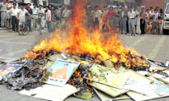
Chinese Regime Burns Religious Books, Jails Believers in War Against Faith

Police routinely monitor private correspondence, search homes, and examine phone records in search of forbidden content such as “reactionary music” from India, according to the latest U.S. State Department report. Provincial officials also banned students from participating in religious activities during school holidays. The report cited 273 Tibetans being “detained in violation of international human rights standards as of late 2019.”

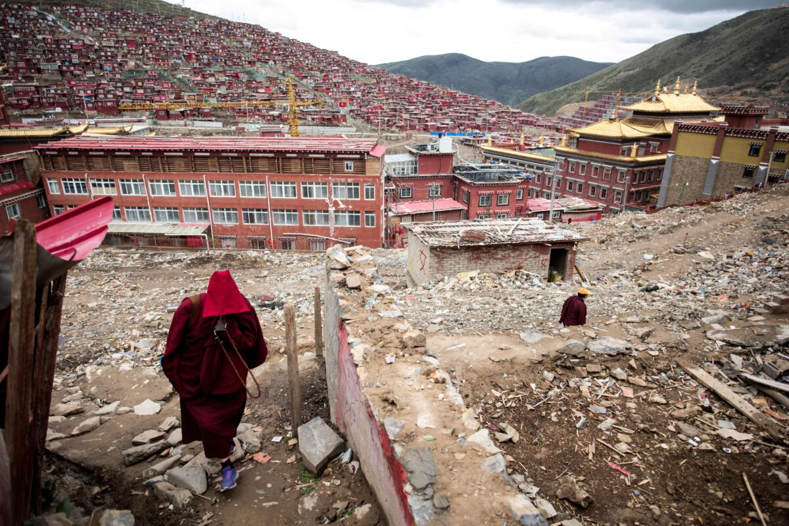
<img class="size-large wp-image-3884648" src="https://img.theepochtimes.com/assets/uploads/2021/07/02/GettyImages-809461812-1200x800.jpg" alt="CHINA-BUDDHISM-RELIGION-RIGHTS" width="640" height="427" /> A nun walking amid the debris of demolished houses at the Larung Gar Buddhist Institute in Sertar county in southwest China’s Sichuan province on May 29, 2017. (Johannes Eisele/AFP via Getty Images)

A Tibetan herder named Lhamo, a 36-year-old mother of three, was detained in June 2020 for sending money to her family in India. The family members who saw her two months later found her “badly bruised and unable to speak,” according to advocacy group Human Rights Watch. She died days later at a local hospital and was immediately cremated.

With the current Tibetan spiritual leader in his 86th year, Beijing has made clear it wants a hand in selecting his successor. In a white paper issued in May, China’s State Council said it had identified and approved “92 reincarnated Living Buddhas”—indicating its intent to choose the next Dalai Lama when the current one passes away.

“The CCP practices a zero-tolerance policy when it comes to religious believers,” Lobsang Tseten, executive director of U.S.-based Tibetan activist group Students for a Free Tibet, told The Epoch Times. He added that the “CCP’s arbitrary rule in Tibet is a direct threat to every aspect of the life of a Tibetan.”

‘Sinicizing’ Churches

The CCP’s suppression of Catholic and Protestant churches has also intensified under current leader Xi Jinping’s watch.

Chinese authorities have removed thousands of crosses from churches, arrested pastors, ordered the removal of Christian images, and aggressively pursued a “sinicization” policy by establishing “patriotic churches,” in which pictures of Jesus Chris and the Virgin Mary are replaced with portraits of Xi or Mao.

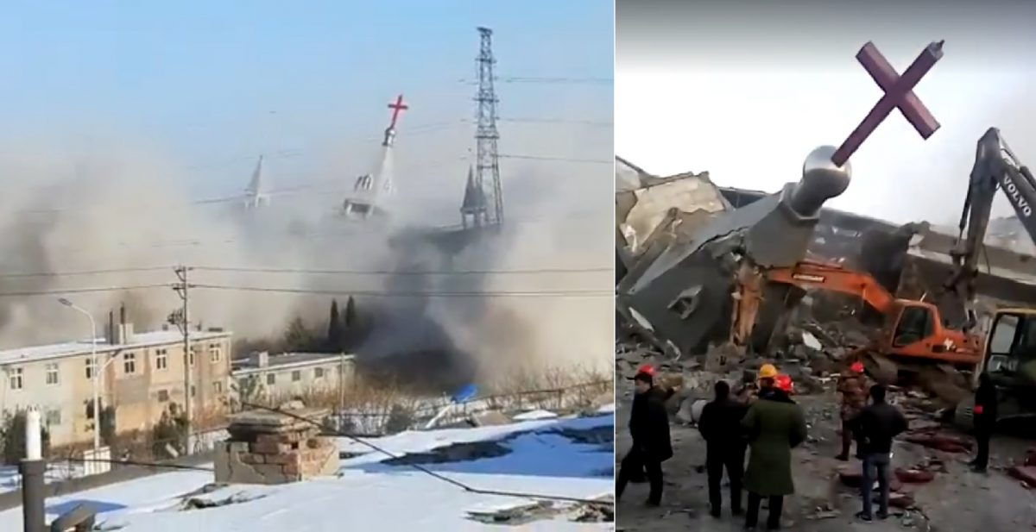
<img class="size-large wp-image-2411798" src="https://img.theepochtimes.com/assets/uploads/2018/01/11/Golden-Lampstand-Church-1200x617.jpg" alt="Epoch Times Photo" width="640" height="329" /> Screenshots from videos uploaded by ChinaAid show the destruction of Golden Lampstand Church in the city of Linfen in China’s Shanxi province on Tuesday, Jan. 9, 2018. (ChinaAid)

The Chinese regime is also reinterpreting and retranslating the Bible to promote “Chinese-style Christianity,” with one Chinese ethics textbook twisting a story from the Bible to have Jesus stone a woman to death while claiming himself a sinner.

In 2017, at least four cities and one province restricted Christmas celebrations, banning displays of Christmas decorations, themed performances, and promotional activities. Communist officials in one university banned activities related to Western religious holidays in the name of helping the younger generation “build cultural confidence.” One Christian this January received a hefty fine of 160,000 yuan ($24,733) for celebrating the holiday.
Underground churches have proliferated as a result of the regime’s oppression. In response, Chinese officials have detained church members and handed lengthy prison sentences to pastors.

Wang Yi, a pastor in central China’s Chengdu who founded one of the country’s largest unregistered Christian churches, was sentenced to nine years in prison in December 2019 for “illegal business operations” and “inciting to subvert state power,” a charge the regime frequently uses to silence dissidents.
In April, Radio Free Asia reported that Beijing was running secret brainwashing facilities, which usually involve torture, in southwestern China’s Sichuan Province to force Christians to give up their faith.

‘Each Day the Party Is Becoming Bolder’

In the far west region of Xinjiang, over 1 million Uyghurs and other Muslim minorities are currently being held in Chinese internment camps—which the regime calls “vocational training centers” ostensibly used for “curbing extremism”—where they face forced labor, torture, sexual abuse, political indoctrination, forced abortion, and forced sterilization.

Led by the United States, a growing number of countries, including Belgium, Canada, the Czech Republic, Lithuania, the Netherlands, and the United Kingdom, have recognized the suppression campaign as a form of genocide.

“The genocide of the Uyghurs is ongoing still, and each day the Party is becoming bolder,” Rushan Abbas, executive director of Washington-based nonprofit Campaign for Uyghurs, said in a June 30 statement, one day ahead of the CCP’s centennial celebration. “This is our final wake-up call that the CCP must be stopped if we are to preserve a global system of dignity and order that is respected by all.”

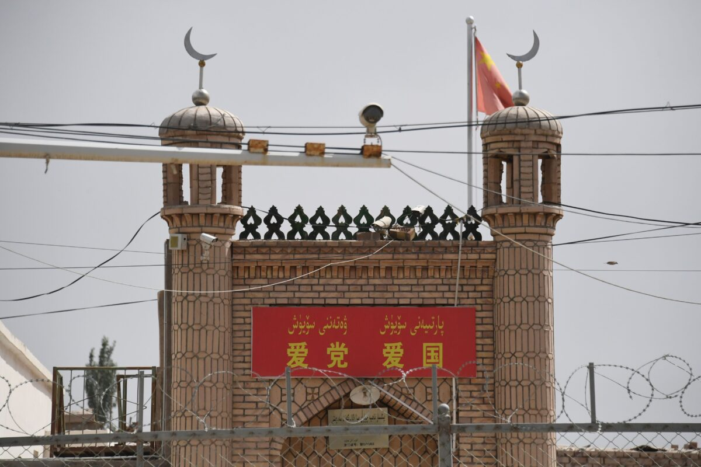
<img class="size-large wp-image-3809755" src="https://img.theepochtimes.com/assets/uploads/2021/05/10/GettyImages-1148084956-1200x800.jpg" alt="Epoch Times Photo" width="640" height="427" /> The Jieleixi No.13 village mosque with slogans “Love the [Chinese Communist] Party, Love China,” in Yangisar, south of Kashgar, in China’s western Xinjiang region on June 4, 2019. (GREG BAKER/AFP via Getty Images)

A recent report by two Washington-based organizations—Oxus Society for Central Asian Affairs and Uyghur Human Rights Project—showed that at least 28 countries in the world were “complicit in China’s harassment and intimidation of Uyghurs.” Many of these countries had strong economic ties to China, including those that have signed up to China’s Belt and Road initiative (BRI, also known as One Belt, One Road).

“As China expands its role globally through the BRI, more states will likely become locked into relations of dependence, increasing China’s ability to coerce or co-opt them to assist in targeting diaspora members and exiles,” according to the report.

‘We Can Make You Disappear’

Nowhere is the CCP’s hatred for religion more evident than in its bloody suppression of practitioners of Falun Gong, a spiritual discipline with slow meditative exercises and moral teachings based on the principles of truthfulness, compassion, and tolerance, according to its website.
Out of fear of Falun Gong’s popularity in China, then-leader Jiang on July 20, 1999, launched a brutal persecution against adherents. Top Chinese officials gave secret orders to “destroy them politically, bankrupt them financially, ruin their reputation,” according to a former military colonel who attended the meeting.

Since then, millions of Falun Gong adherents have been held in prisons, labor camps, psychiatric hospitals, and other detention facilities in China. Hundreds of thousands have been tortured in those venues in a bid to force practitioners to give up their belief. An untold number have died under China’s state-sanctioned forced organ harvesting, with their organs cut out to be sold on the transplant market.

The persecution has continued to this day.
Over the first five months of 2021, 599 Falun Gong practitioners are documented to have been sentenced for their faith; one of them, 81 years old, received nine years, according to data from Minghui.org, a U.S.-based website that monitors the persecution of the faith group. More than 15,000 were documented to have experienced harassment or arrests last year.

Related Coverage

Lured by handsome bonuses, police and local officials last year began a sweeping “Zero-Out Campaign” going after adherents country-wide, Minghui reported. The adherents were told to sign a statement renouncing their faith or see their pensions, careers, or children’s education imperiled.
“We can make you disappear if we say the word,” one officer from China’s northernmost province Heilongjiang allegedly told an adherent.

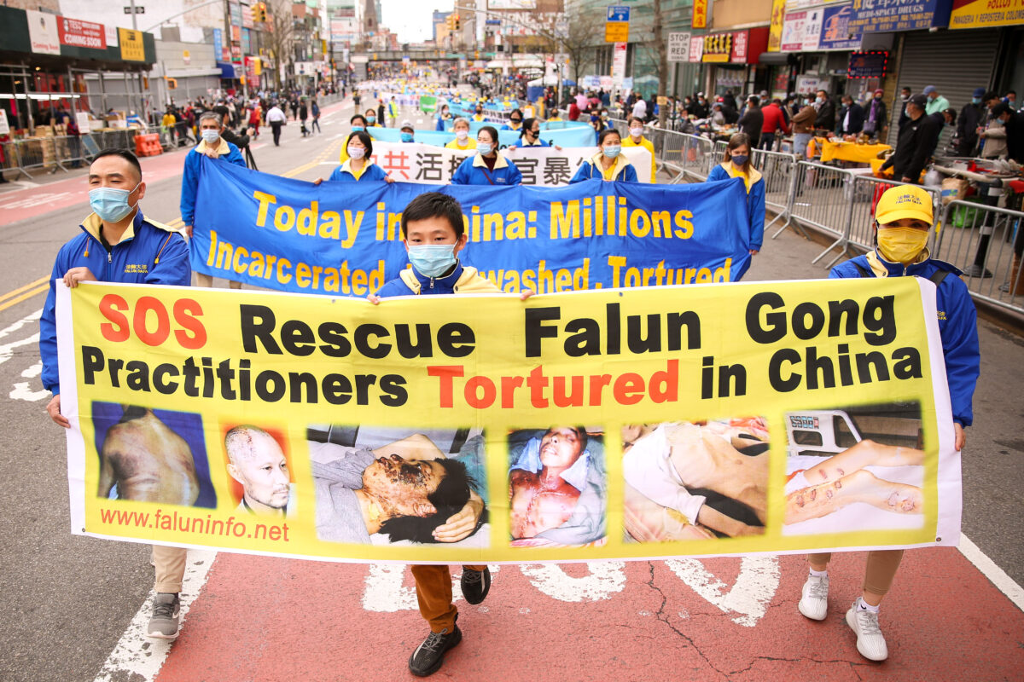
<img class="size-large wp-image-3781104" src="https://img.theepochtimes.com/assets/uploads/2021/04/18/Epoch-Times-676A6815-1200x800.jpg" alt="Epoch Times Photo" width="640" height="427" /> Falun Gong practitioners take part in a parade in Flushing, New York, on April 18, 2021, to commemorate the 22nd anniversary of the April 25th peaceful appeal of 10,000 Falun Gong practitioners in Beijing. (Samira Bouaou/The Epoch Times)

Guo Zhenfang, from Chifeng city in Southeastern Inner Mongolia, died in June, one day after his trial. At the hospital, his family found bloodstains on his nose and a wound around his knee cap. His back from the waist down had turned “purple-red,” according to Minghui. Dozens of plain-clothed police officers blocked the family from further examining the body and sent it to the crematorium without their consent.

Lü Songming, a former history teacher at a middle school from southern China’s Hunan Province, spent a total of 14 years in jail. He lost around 20 teeth to beating, forced labor, electrocution, and other forms of torture. When he was released in 2018, he had only six teeth left and was no longer fit to work. He suffered from frequent heart failure, eventually dying in March at the age of 53.

‘A Real Weakness’

Brownback observed that increasingly in Xi’s China, brutal, inhumane tactics from the Mao era are making a comeback.
But in its rush to assert power over China’s faithful, Brownback said, the regime is “showing a real weakness.”
“They must be feeling the loss of control, and so they are being far more repressive and brutal,” he said.
Beijing’s human rights and religious freedom abuses are costing the regime its global image, while at home, it is hurting its ability to maintain its rule, said Brownback.
“Communism and faith just have great trouble co-existing, and faith will not be subdued, so eventually the communism will fall,” he said.
What remains of the CCP’s 100-year legacy, said Pastor Fu, will be its record as “the single political party through which the largest number of human lives were arbitrarily lost … in the whole of human history.”

Conclusion

Christ’s enemies were successful in crucifying Him but not destroying God’s plan. Jesus overcame every enemy, and certainly death, so that we as His followers would have hope and be set free by His absolute victory (Matthew 22:44; Phillippians 2:9-11).
Jesus made it clear that Christians would face many enemies because of their faith in Him: “In fact, everyone who wants to live a godly life in Christ Jesus will be persecuted” (1 Timothy 3:12; John 15:18-19; 17:14).

Christ also provided an example for Christians to follow whenever they faced enemies of God and their threats: “To this you were called, because Christ suffered for you, leaving you and example, that you should follow in his steps. ‘He committed no sin, and no deceit was found in hs mouth.’ When they hurled their insults at him, he did not retaliate; when he suffered, he made no threats. Instead, he entrusted himself to him who judges justly. ‘He himself for our sins’ in his body on the cross, so that we might die to sins and live for righteousness; ‘by his wounds you have been healed’” (1 Peter 2:21-24).

The Bible instructs us as believers to be cautious yet courageous when dealing with the enemies of God: “Be sober-minded; be watchful. Your adversary the devil prowls around like a roaring lion, seeking someone to devour” (1 Peter 5:8)

The enemies of God are fighting a losing battle: “Surely your enemies, Lord, surely your enemies will perish; all evildoers will be scattered” (Psalm 92:9). The final enemy of God to be eradicated is death: “For he must weigh until he has put all His enemies under his feet. The last enemy to be destroyed is death” (1 Corinthians 15:25-26; 2 Timothy 1:10; Revelation 21:4)

gotquestions.org

